**Hello World RESTful Web Service**   
  
**Write a REST service in the spring learn application created earlier, that returns the text "Hello World!!" using Spring Web Framework.**

**CODE:**

pom.xml

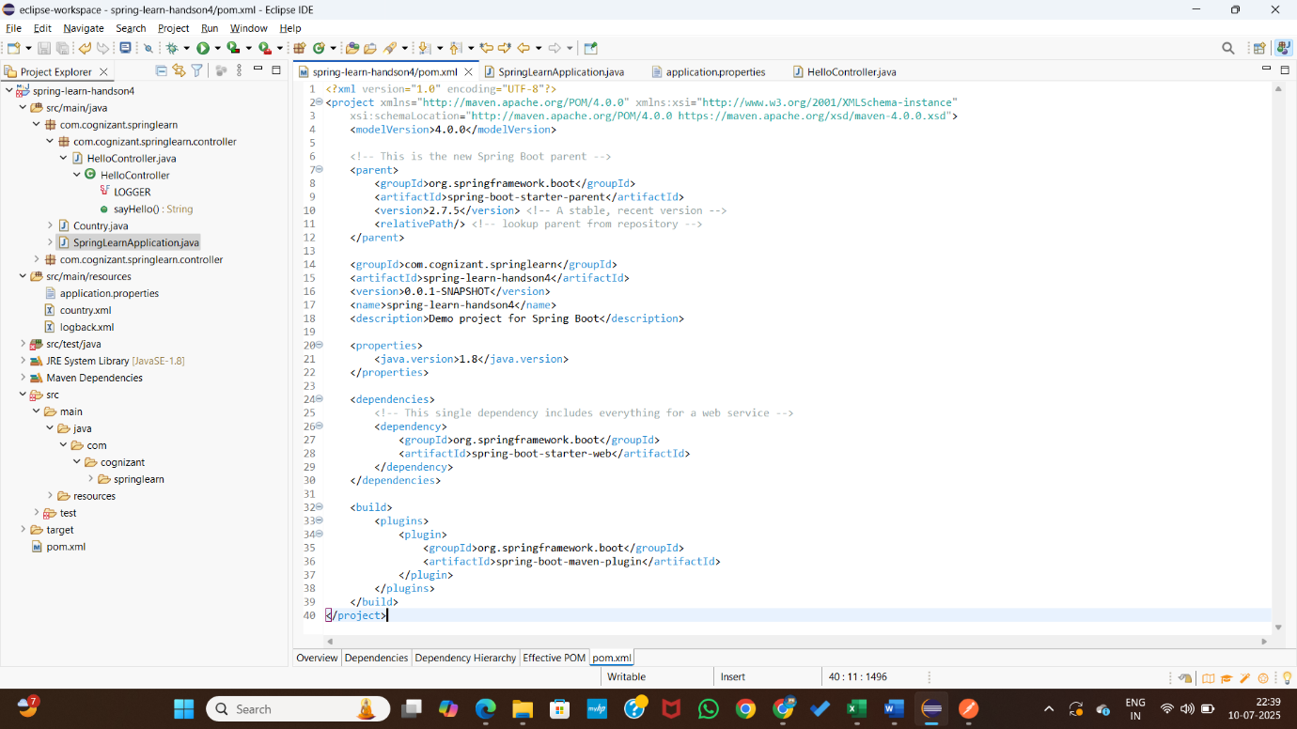

SpringLearnApplication.java :

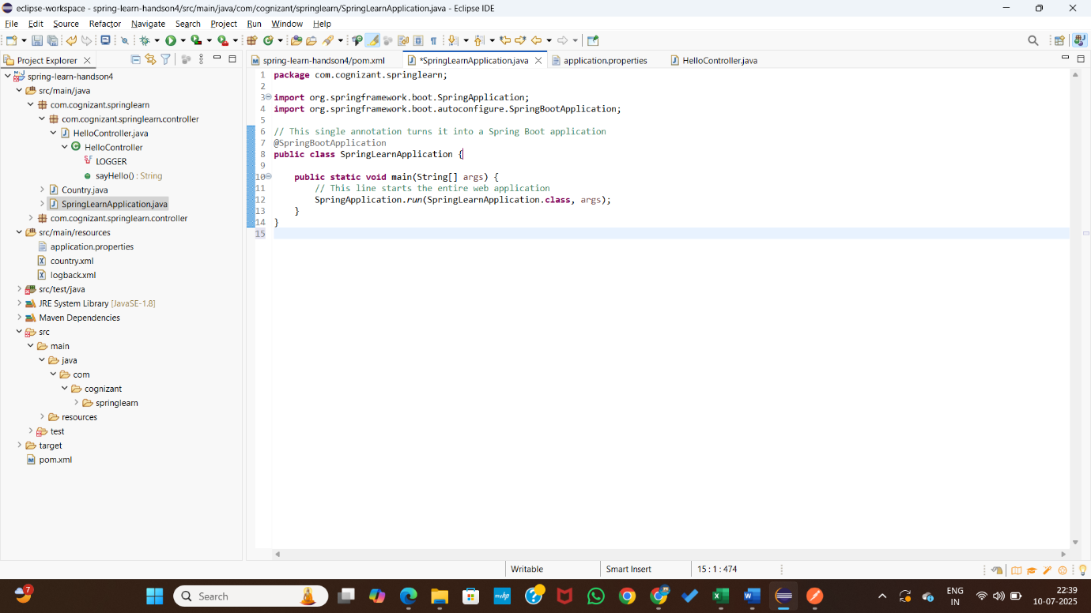

Application.properties :

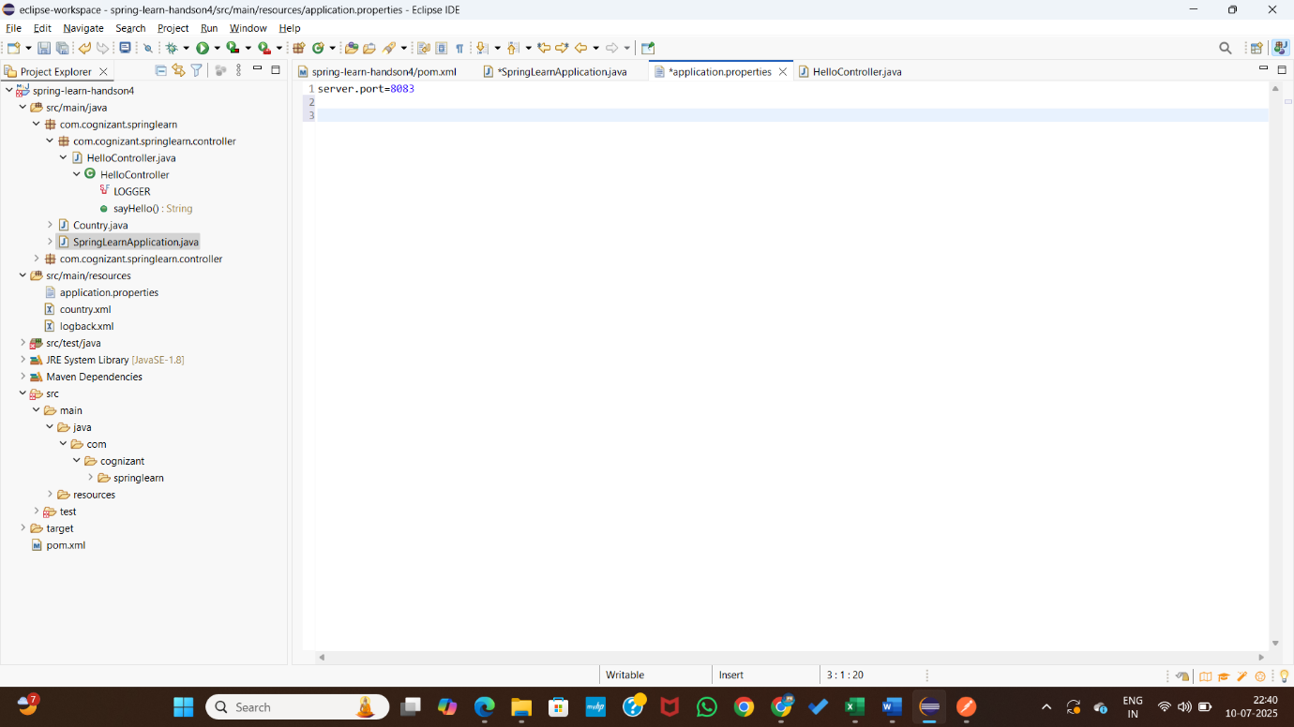

HelloController.java :

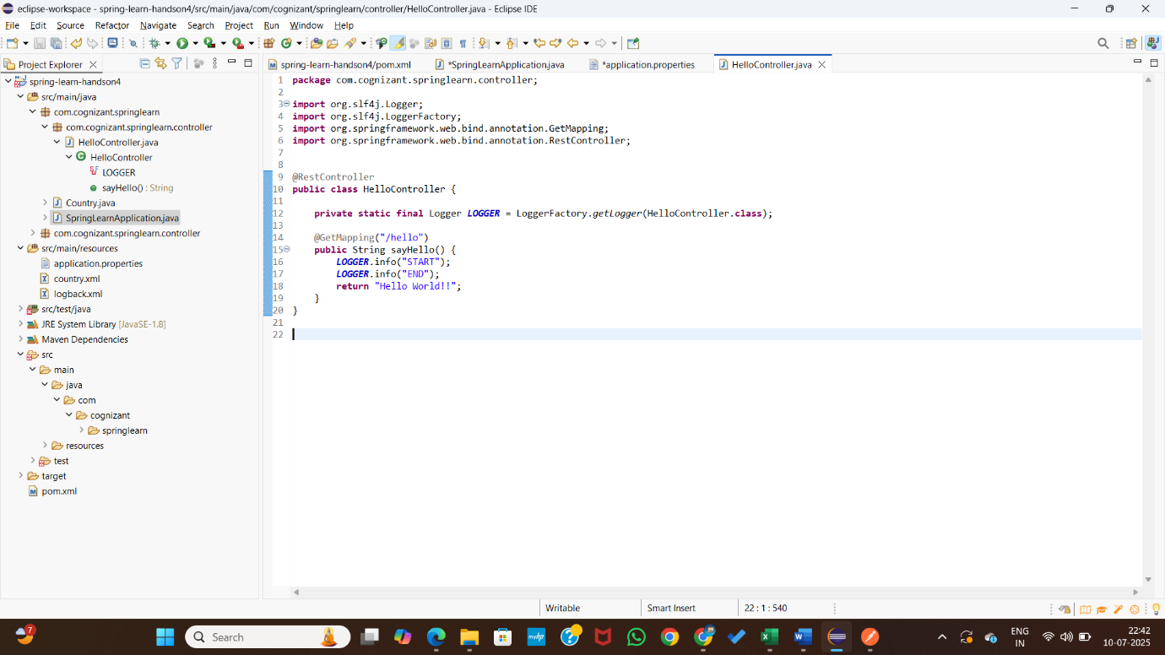

**OUTPUT :**

